**While Statements to CFG**

[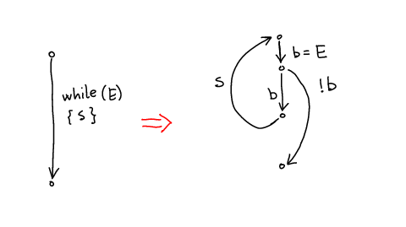](http://lara.epfl.ch/web2010/_detail/cc09:tr-while-cfg.png?id=cc09%3Awhile_statements_to_cfg&cache=cache)

Note: better translation uses two destination vertices